**TUTORIAL 2 (REPLACEMENT)**

1. The following diagram shows number of students in a school who plays one of three sports.

ξ

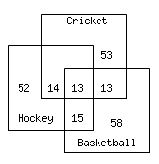

1. How many students who play Hockey and Cricket?
2. Represent Cricket with C, Hockey with H and Basketball with B.

On the diagram above, shade the region for the set .

[3 marks]

1. Given the relations {(1, 1), (2, 2), (1, 3), (3, 2), (1, 2)} on the set {1, 2, 3}. Identify whether the relations given is reflexive, symmetric and/or transitive? Explain your answer.

[3 marks]

1. Illustrate the graph for the function ⎡⎤ for the range of .

[3 marks]

1. Let and . Compute

[2 marks]